1. **What is the 52 week high and low for all the items traded in the past 3 months?**

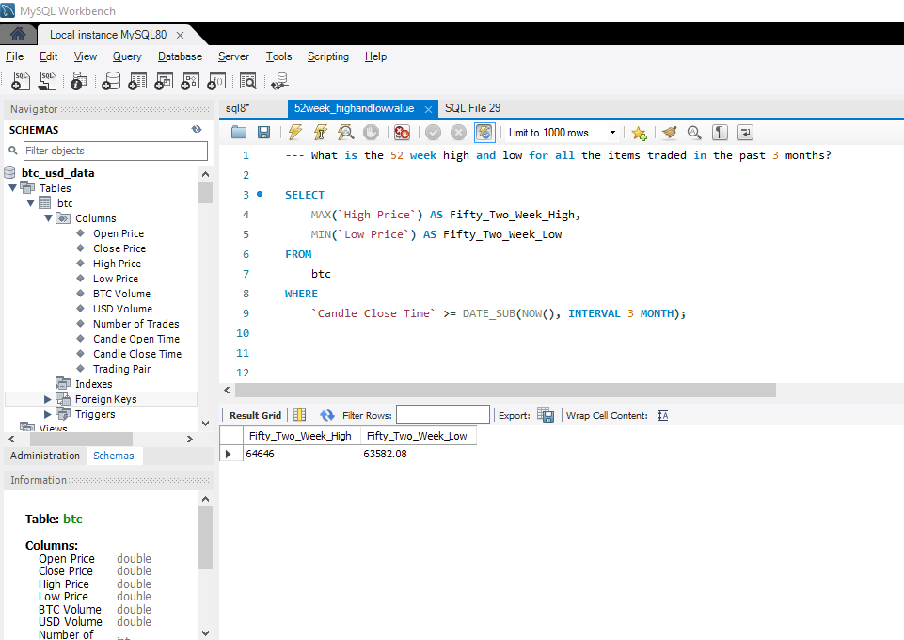

1. **What is the high/low price/volume in the past 2 hours?**

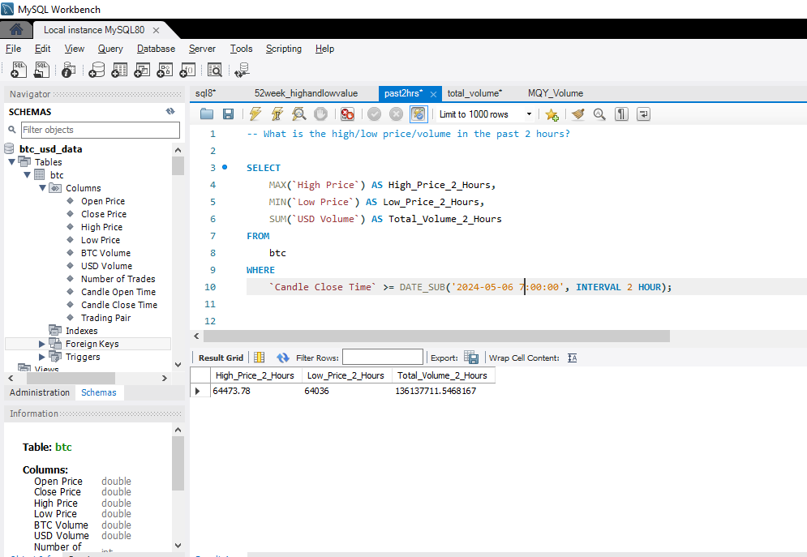

1. **What is the volume for a given timeframe?**

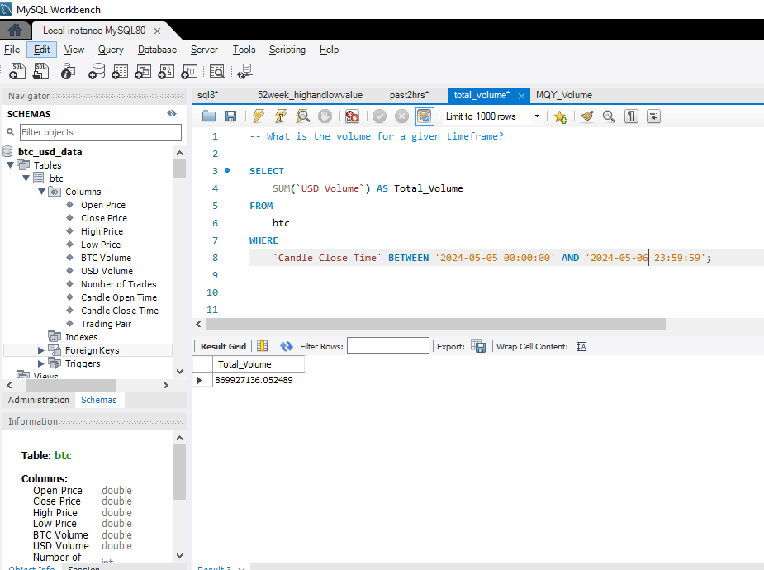

1. **Monthly, quarterly, and yearly volume for items that have 10 million+ in volume over the past year?**

I have calculated only Monthly volume for May 2024 month, as I have extracted 2 days data only and have set limit up to 1000 for data extraction.

